Somerset County Health Department

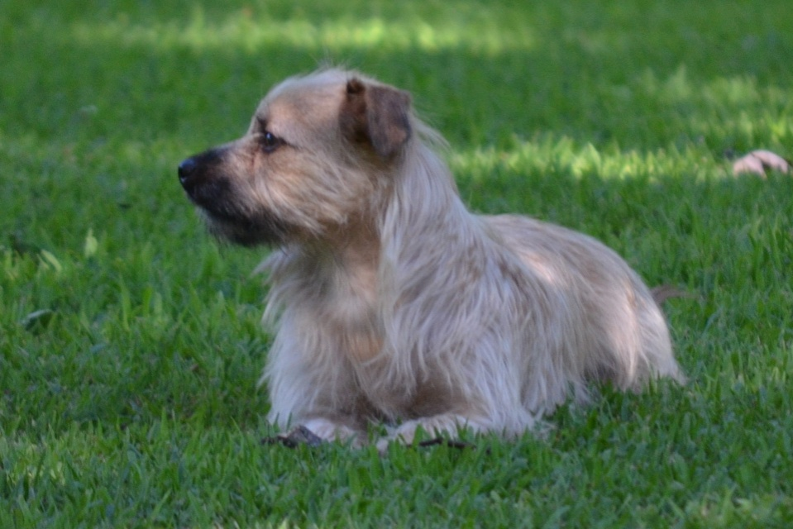

Spring Rabies Clinics

Tuesdays 6:00 p.m. – 8:00 p.m.

Deal Island Fire Department March 20, 2018
Mt. Vernon Fire Department March 27, 2018
Princess Anne Fire Department April 3, 2018
Marion Fire Department April 10, 2018
Crisfield Fire Department April 17, 2018
Fairmount Fire Department April 24, 2018

The fee for each vaccination is $8.00.

For animals to receive a three (3) year vaccination, please present a current vaccination certificate. Otherwise all shots will be for one (1) year.

For more information, please call the Health Department at 443-523-1730.

